**Sorting Visualizer Documentation:  
  
Introduction:**

* The Sorting Visualizer is an interactive web application that demonstrates the step-by-step process of various sorting algorithms through visual representation. This educational tool helps users understand how different sorting algorithms work by displaying real-time animations of the sorting process. The application currently implements two fundamental sorting algorithms: Bubble Sort and Selection Sort, making it an excellent resource for students and developers learning about sorting algorithms.

**Requirements:**

* Python 3.7 or higher
* Web browser with JavaScript enabled

**Technologies:**

* Python, Html, CSS, JavaScript

**Screenshot:**

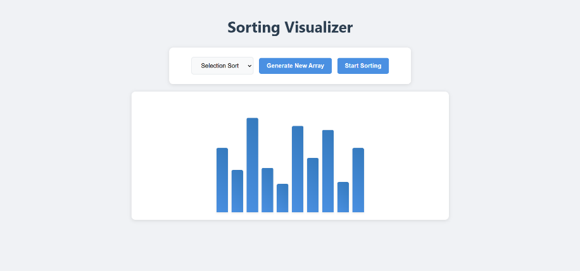

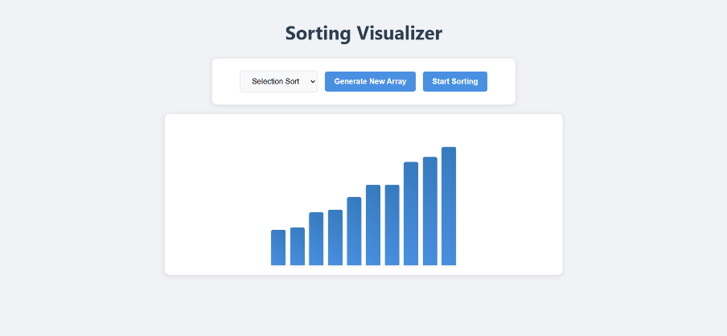

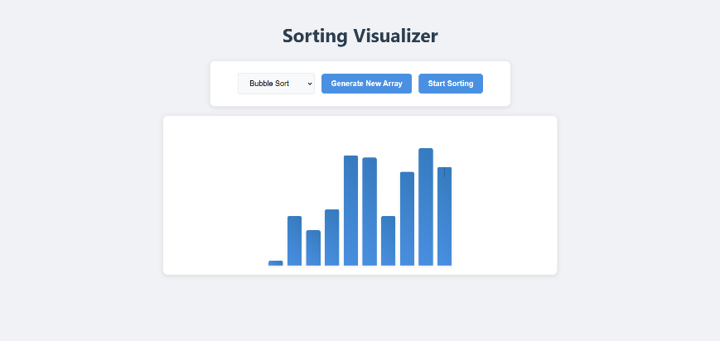

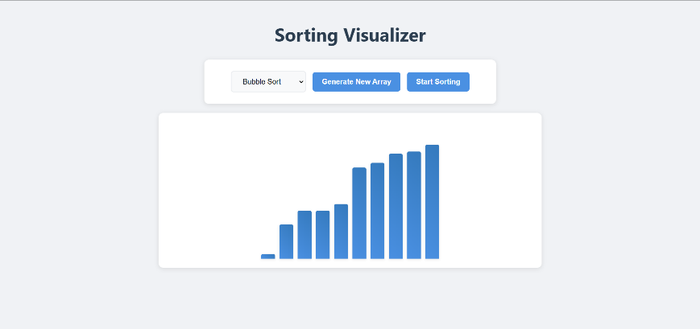

**Conclusion:**

The Sorting Visualizer project successfully demonstrates the implementation of sorting algorithms through an interactive and visually appealing interface. The combination of Flask backend and vanilla JavaScript frontend provides a lightweight yet powerful solution for algorithm visualization. The project serves as both an educational tool and a demonstration of modern web development practices.